**Chapter 20, 21,& 22 Evolution Test**

**Do not write on the Test**

**Multiple Choice:**

1. Natural selection as a mechanism of evolution that acts on variants within populations and ultimately leads to the evolution of different species was proposed by

1. A. Mendel. B. Lyell. C. Malthus. D. Darwin. E. Founder.

2. Features that increase the likelihood of survival and reproduction by an organism in a particular environment are called

1. genes. B. fitness. C. mutations. D. adaptations. E. selection.

3. In humans, muscles that move the ears are_____ structures.

1. A. Homologous B. Essential C. Original D. vestigial

4. The passing on of good traits to succeeding generations, compared with that of other individuals in the population, is known as

1. A. variation. B. microevolution. C. macroevolution. D. fitness. E. adaptive makeup.

5. Darwin proposed that natural selection occurs in an environment by

1. favoring heritable features that make the organism better suited to survive and reproduce.
2. producing a constant number of offspring while in that environment.
3. surviving for a fixed amount of time.
4. resisting the environment and keeping the environment from changing.
5. favoring those individuals with the most favorable acquired characteristics.

6. The frequency of a particular allele within a population can be changed, over time, by

1. genetic outflow.
2. large population size.
3. selection.
4. inheritance of acquired characteristics.
5. random mating

7. Biologists examined the question of variation in different genes through studies on

A. blood and enzymes. B. enzymes only. C. learning only. D. enzymes, and learning. E. bonding

8. A locus with more variation than can be explained by mutation is referred to as   
A. dominant. B. polynomial. C. polymorphic. D. heterozygous. E. somatic.

9. Which one of the following is not an agent of natural evolutionary change?

A. mutation B. migration C. genetic drift D. non-random mating E. artificial selection

10. In small populations, frequencies of certain alleles may change by chance alone. Such random change in the frequency of alleles is called

A. mutation. B. migration. C. genetic drift. D. nonrandom mating. E. selection.

11. Which one of the following is not an agent of evolutionary change?

A. mutation B. gene flow C. random mating D. genetic drift E. selection

12. About 80% of the alleles present in thoroughbred horses can be dated back to 31 known ancestors from the late eighteenth century. As a result, one would expect

A. low rates of mutation. B. many polymorphic alleles. C. little variation in physiology and behavior.

D. Hardy-Weinberg equilibrium. E. random mating.

13. Natural Selection can only operate on an individual species

A. gene pool B. gene frequency C. phenotypic variation D. genotypic variation

14. Which of the following examples is not evidence that natural selection is at work?

A. The color of a caterpillar larva matches the color of the leaves of its host plant.

B. Turtles hatched from eggs in moist sand are larger than those hatched from eggs in dry sand.

C. A species of lizard is dark if it lives on cooled lava, but white if it lives on sand.

D. Enzyme polymorphism in a widespread species changes with geography.

E. An insect population becomes resistant to a commonly used insecticide.

15. Natural selection varies the shape of the beaks among Darwin's finches in response

A. to the available food supply. B. to the available nest building material supplies.

C. to the availability of potential mating partners. D. to presence of ectoparasites on their feathers.

E. to the need to improve their feather preening abilities.

16. A technique used in dating a rock can be used to accurately predict the age of the fossils occurring in the rocks. This technique involves

A. fossil dating. B. successive rock layering. C. radioactive isotope decay.

D. structural geology. E. developmental geology.

17. The evolution of similar forms in different lineages when exposed to the same selective pressures is

A. called divergence. B. called convergence. C. referred to as successive homologies.

D. referred to as descent. E. also known as natural selection.

18. Industrial melanism is a term describing

A. the color change induced by living in industrialized areas.

B. the darker moths having higher mutation rates because of industrialization.

C. the evolutionary process in which initially light-colored organisms become dark as a result of natural selection.

D. the darker moths having higher reproductive success because of their pigmentation.

E. the widespread implementation of pollution controls.

19. The evidence for industrial melanism as being due to an increase in the dark allele was provided from field tests carried out by

A. Kettlewell. B. Lamarck. C. Darwin. D. Lamarck. E. Wallace.

20. Evidence for evolution includes all of the following except

A. the fossil record. B. homologous structures. C. the molecular record.

D. intelligent design. E. vestigial structures.

21. According to Darwin, any inherited characteristic that increases an organism’s fitness for survival is a(n)

A. deletion B. Adaptation. C. Gene D. Allelel

22. Which of the reasons does not explain why "scientific creationism" cannot be considered a science?

A. It is not supported by any empirical observations.

B. It does not obtain its principles from observation, as does science.

C. Its assumptions lead to no hypotheses that could be tested and possibly disproved.

D. The idea of creation by a supernatural agency lies outside the realm of science.

E. Only non-scientists believe it.

23. Which of the following is an example of convergent evolution?

A. Australian marsupials and placental mammals of other continents

B. analogous organs of horses, antelopes, and deer

C. homologous organs of apes and humans

D. skull bones of vertebrates

E. all of the species in a genus of placental mammals

24. Industrial melanism involving the peppered moths (*Biston* *sp*.) is cited as an example of natural selection that has been observed in the last one hundred years. Recall that the peppered moth exhibits two distinct morphological types with dark and light colored wings. Which of the following statements about changes in these two types of moths as a result of industrial melanism is true?

A. The dark forms are selected against in nonpolluted forests.

B. The dark forms are distasteful to birds and are thus safe in polluted forests.

C. The light forms are selected against in nonpolluted forests.

D. Birds prey on the dark and light forms equally and neither morph has an advantage.

E. Dark forms emigrate from nonpolluted forests to polluted forests.

25. You see a sign on a door that reads "Homologous Structures Inside." You go in and find

A. structures of animals that appear to have evolved from different parts of their bodies.

B. structures of animals that have difference appearances and functions but seem to have evolved from the same body part in a common ancestor.

C. structures of animals that have the same appearances and functions but obviously no common ancestor.

D. structures of animals that have different appearances and functions but different ancestors.

26. The model assumes that evolution occurs in spurts, between which there are long periods of stasis with little evolutionary change.

A. successive descent model. B. punctuated equilibrium. C. gradualism.

D. the allopatric model. E. the sympatric model.

27. New species can not arise without

A. homologous structures B. analogous structures C. overlapping niches D. Reproductive isolation

28. The basic unit of evolution and taxonomy is the   
A. ecosystem. B. population. C. species. D. community. E. niche.

29. The distinctive role of a species in nature is its   
A. fitness. B. adaptation. C. habitat. D. niche. E. life cycle.

30. One original organism gives rise to other different species by the process called

A. fitness B. Adaptation C. convergent evolution d. inherited traits.

31. Natural selection promotes speciation by all of the following except   
A. strengthening isolating mechanisms. B. restricting gene flow. C. character displacement.

D. promoting polyploidy. E. affecting the survivorship of hybrids.

32. Adaptive radiation is likely to produce several    
A. key innovations. B. species clusters. C. sterile hybrids.

D. reproductive isolating mechanisms. E. races.

33. The Age of the fishes is known as the

A. Precambrian B. Cambrian C. Devonian D. Ordivician E. Carboniforous

34. A virgin pine forest covers a valley, and one of the inhabitants is a red squirrel species. A large volcanic eruption occurs and separates the valley with a huge lava flow that the squirrels cannot cross, thus producing two isolated populations of squirrels. What change needs to occur for the two populations of squirrels to become separate species?

A. The two squirrel populations must eat distinct species of plants.

B. The area that the squirrel populations occupy changes so that the squirrel populations exist in distinct habitats.

C. The fur color of the two squirrel populations must become distinct.

D. The two squirrel populations select mates using the same sexual behavior.

E. The two squirrel populations become reproductively isolated.



35. Diversity through time is represented by the figure shown. Select the statement that presents an accurate interpretation.

A. There were more families of organisms during the Ordovician than the Tertiary.

B. There were more families of organisms during the Cambrian than the Carboniferous.

C. There were more families of organisms during the Jurassic than the Tertiary.

D. There were more families of organisms during the Cretaceous the Tertiary.

E. There were more families of organisms during Tertiary than the Cambrian.

36. Diversity through time is represented by the figure shown. Following periods of extinction the total numbers of families of organisms

A. usually recovered within a million years or less, showing remarkable adaptive radiation.

B. usually recovered within about ten million years, and have increased since the beginning of life.

C. usually recovered within about ten million years, indicating the mechanism is probably punctuated equilibrium.

D. usually did not recover at all-the total numbers gradually decline over time.

37. A classical example of adaptive radiation is seen in

A. peppered moths. B. mules. C. Darwin's finches.

D. Hawaiian finches. E. mainland birds.

38. In the southeastern U.S., two species of wild lettuce (*Lactuca*) do not usually form hybrids, because they bloom at different seasons. The means of isolation appears to be

A. behavioral. B. temporal. C. geographical. D. mechanical. E. ecological.

39. Two groups of organisms that differ from one another in one or more characteristics and do not reproduce extensively or have viable offspring if they occur together in nature are considered to be different

A. races. B. species. C. kingdoms. D. hybrids. E. cohabitants

40. The distinctive role of a species in nature is its

A. fitness. B. adaptation. C. habitat. D. niche. E. life cycle.

Essay:

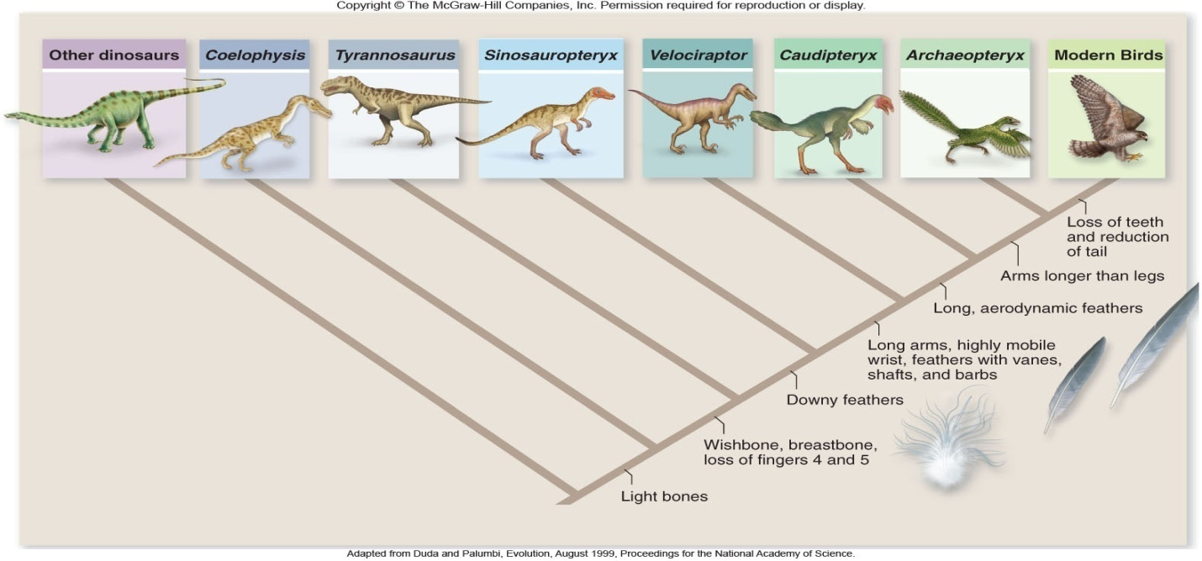

41. Summarize at least three important facts that might be obtained from the above cladogram. (4 pts.)

42. In the example we used in class the (R) gene is dominant and codes for furry bunnies. (r) is recessive and codes for naked bunnies. (rr) bunnies are naked and don’t survive to reproduce. (RR) and (Rr) are furry and survive. Why is it so difficult to eliminate negative recessive genes from a population? (3 pt.)